Latest news – Older news – PBK

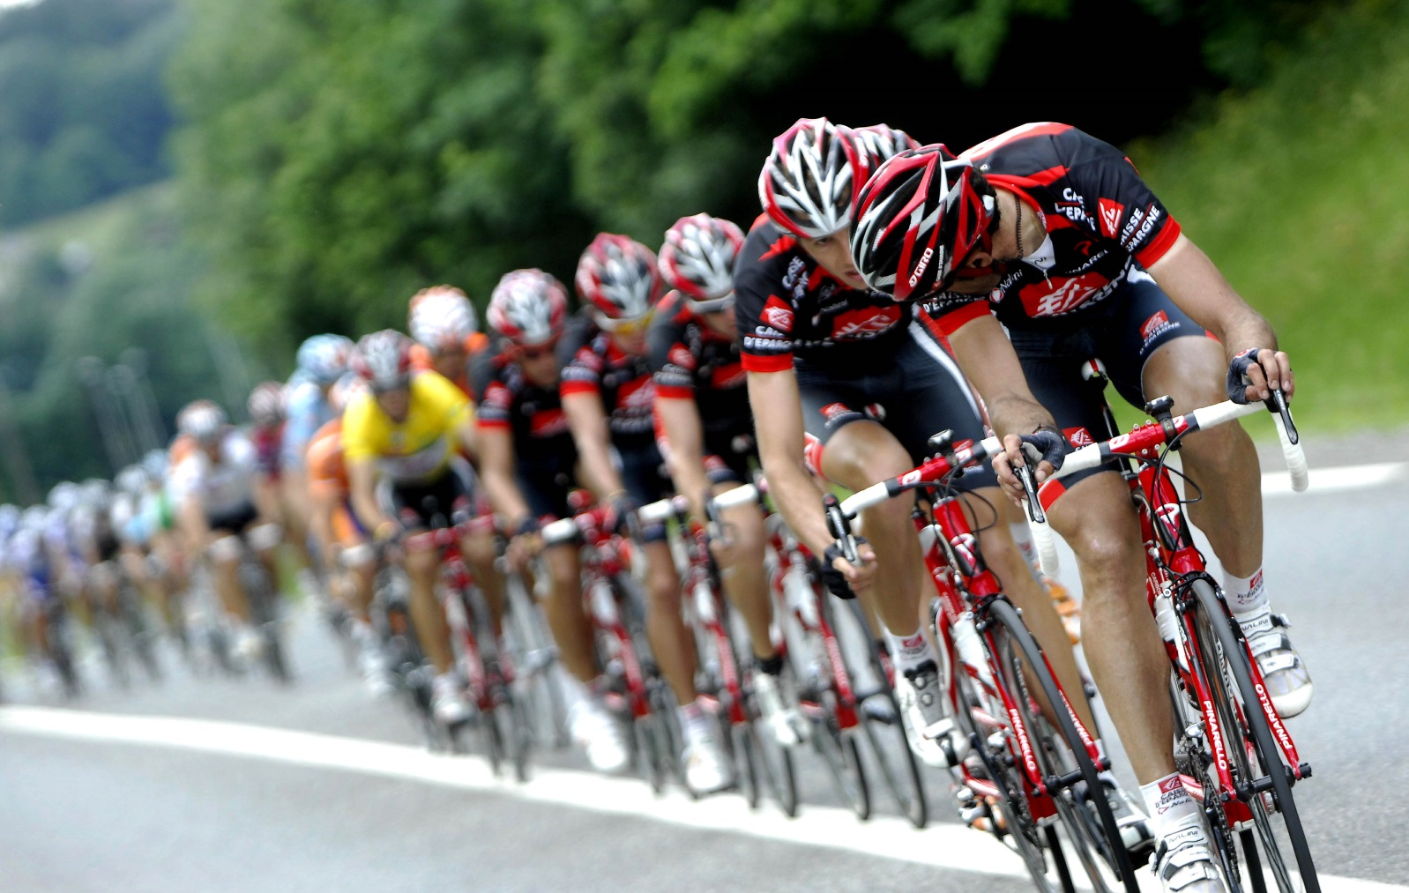

Header 1:
Encore generate 4x return with sale of PBK
Main Copy:

10th January 2013
Encore Capital LLP (“Encore”), the London based investment firm focused on backing entrepreneurial growth businesses, has completed the sale of portfolio company Pro Bike Kit Limited (PBK) to The Hut Group Limited, one of Europe’s fastest growing online retailers.
Established in 1998, PBK is a leading online road cycling retailer, with a global reach, an authentic brand heritage and an authoritative proposition of premium brands.
Encore invested in the business in August 2011. As part of its investment strategy it built out the senior management team and worked closely with the business to develop and execute a clear strategic plan. These actions helped to enhance growth and increase business capability particularly in technology, marketing and supplier relationships. This led to an acceleration in growth for the business, cementing PBK’s position as a prominent player in the global road cycling market.
Encore, who owned a majority equity stake, appointed and worked closely with Steve Robinson, former CEO of M and M Direct, as Chairman of PBK. The exit was completed on 22 January 2013 generating a 4 times money multiple return on investment for Encore in under 18 months.
Matthew Moulding, Chief Executive of The Hut Group said “Following a review of the sector we identified PBK as the outstanding brand for acquisition given its heritage, the breadth and longevity of its supplier relationships and its international customer reach. Through our due diligence it quickly became apparent that Encore had created a stable and professionalised platform ideal for The Hut Group to enter the specialist cycling and triathlon markets.”
Commenting on the transaction, Khilan Dodhia, Partner at Encore, added: “When we were introduced to PBK we immediately recognised the opportunity presented and managed to conclude a transaction extremely quickly. PBK management were seeking a partner capable of transitioning them away from an owner-managed business to one that could scale and maintain a leading position in a fast growing market. Our track record of success in similar situations gave them comfort that Encore was the right partner for them. We are delighted to have exited the business to online retail specialist The Hut Group, with whom we have shared a strong relationship over the past few years"

